Gesture Recognition by Lydia Sharon James and Paratyaksh Singh

Problem Statement:

Imagine you are working as a data scientist at a home electronics company which manufactures state of the art smart televisions. You want to develop a cool feature in the smart-TV that can recognise five different gestures performed by the user which will help users control the TV without using a remote.

- Thumbs up : Increase the volume.
- Thumbs down : Decrease the volume.
- Left swipe : 'Jump' backwards 10 seconds.
- Right swipe : 'Jump' forward 10 seconds.
- Stop : Pause the movie.

Objective:
To develop and train a hand gesture recognition network to over come the problem statement and developed with multiple iterations of the same to find the best combination of neural networks.

Results:

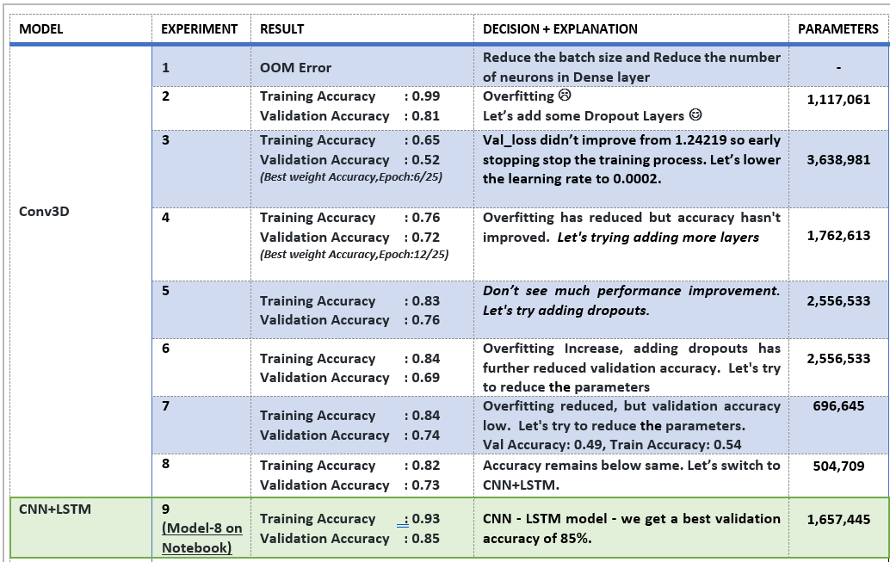

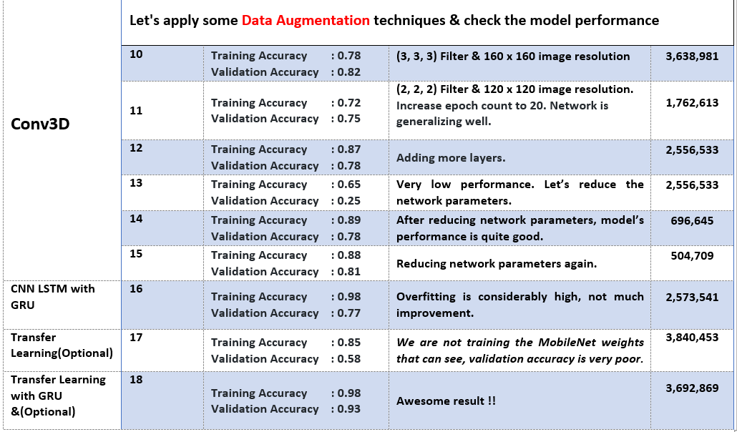

Observations:
- It was observed that as the Number of trainable parameters increase, the model takes much more time for training.
- Batch size ∝ GPU memory / available compute. A large batch size can throw GPU Out of memory error, and thus here we had to play around with the batch size till we were able to arrive at an optimal value of the batch size which our GPU could support ( NVIDIA Tesla K80 GPU with 12GB memory provided by nimblebox.ai platform.)
- Increasing the batch size greatly reduces the training time but this also has a negative impact on the model accuracy. This made us realise that there is always a trade-off here on basis of priority -> If we want our model to be ready in a shorter time span, choose larger batch size else you should choose lower batch size if you want your model to be more accurate.
- Data Augmentation and Early stopping greatly helped in overcoming the problem of overfitting which our initial version of model was facing.
- CNN+LSTM based model with GRU cells had better performance than Conv3D. As per our understanding, this is something which depends on the kind of data we used, the architecture we developed and the hyper-parameters we chose.
- Transfer learning boosted the overall accuracy of the model. We made use of the MobileNet Architecture due to it’s light weight design and high speed performance coupled with low maintenance as compared to other well-known architectures like VGG16, AlexNet, GoogleNet etc.

